Look at these butterflies and flowers. All of them have a number.

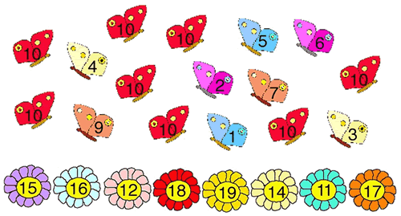

Can you find two butterflies to go on each flower so that the butterfly numbers add to the flower number?
Which pair of butterflies has no flower to go to? Why?
Which flower cannot have a pair of butterflies on it? Why?

Read about how three children started this task:

Zac said:
I noticed there were eight butterflies which all had the number 10 on them, so I put one on each flower.

Mona said:
I picked two butterflies and added their numbers together.

Anita said:
I noticed that if I added two red butterflies together I didn't get a flower total.

Did you start the problem in the same way as any of these children?
What do you think about each method?

