In the problem “Latin Numbers”, you are challenged to find a six-digit number N with a special property.
If you double the number and write it in the second row,
treble the number and write it in the third row, and so on...
you end up with a Latin Square (i.e. the same six digits appear in every row and column).

N:
2N:
3N:
4N:
5N:
6N:
If you’re not sure where to start, take a look at the grid below.
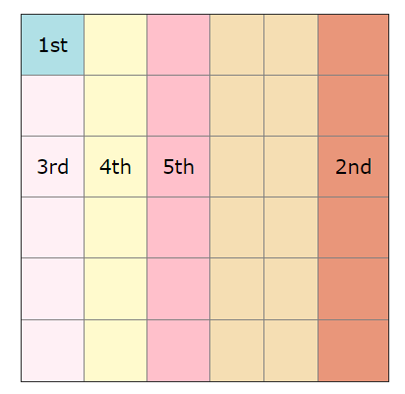
The bottom row is six times N…
Does this help you to work out which number goes in the square labelled 1st?
What can you say about the last digits of 2N, 4N, and 6N? Or the last digit of 5N?
Does this help you to work out any of the numbers in the column labelled 2nd?
Every row and every column contains the same six digits.
Does this help you to work out the 3rd, 4th, and 5th shaded sections?

