The picture below shows a 4 by 4 Latin square.
If you haven’t come across Latin Squares before, have a look and see if you can spot what is special about it.
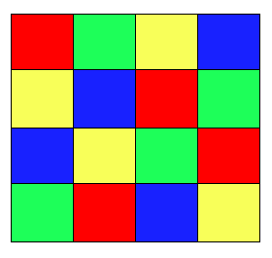
In a Latin Square each symbol or colour occurs exactly once in each row and exactly once in each column.

In the grid below, N is a 6 digit number with a special property:
if you double the number and write it in the second row,
treble the number and write it in the third row,
and so on...
you end up with a Latin Square!
N:
2N:
3N:
4N:
5N:
6N:
Can you find the six digit number N?

