Here is a clock face where the numbers have become all mixed up. In the picture, each of the numbers is represented by a letter. Can you find out which letter represents which number using the ten statements below?
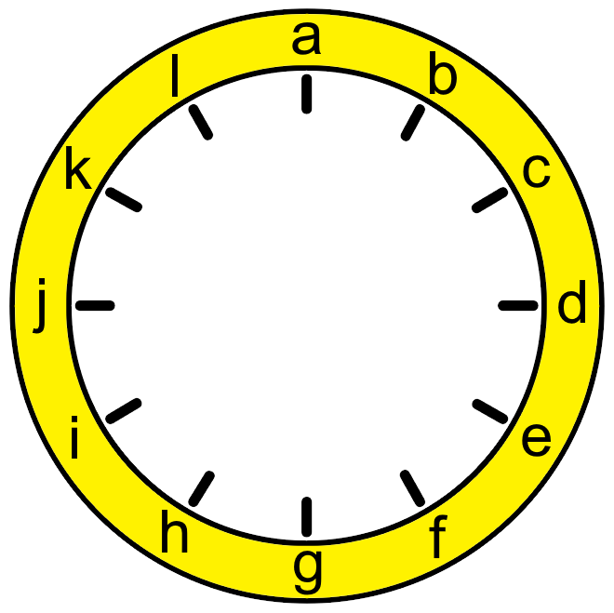
- No even number is between two odd numbers.
- No consecutive numbers are next to each other.
- The numbers on the vertical axis (a and g) add to 13.
- The numbers on the horizontal axis (d and j) also add to 13.
- The first set of 6 numbers (a, b, c, d, e, f) add to the same total as the second set of 6 numbers (g, h, i, j, k, l).
- The number at position f is in the correct position on the clock face.
- The number at position d is double the number at position h.
- There is a difference of 6 between the number at position g and the number before it (f).
- The number at position l is twice the top number (a), one third of the number at position d and half of the number at position e.
- The number at position d is 4 times one of the numbers next to it.

