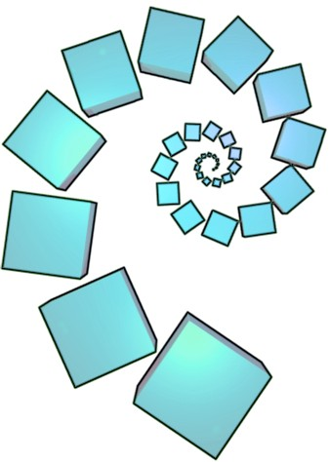
Missing Middles

Find the domino to go in the middle to complete each pattern of 3 dominoes.
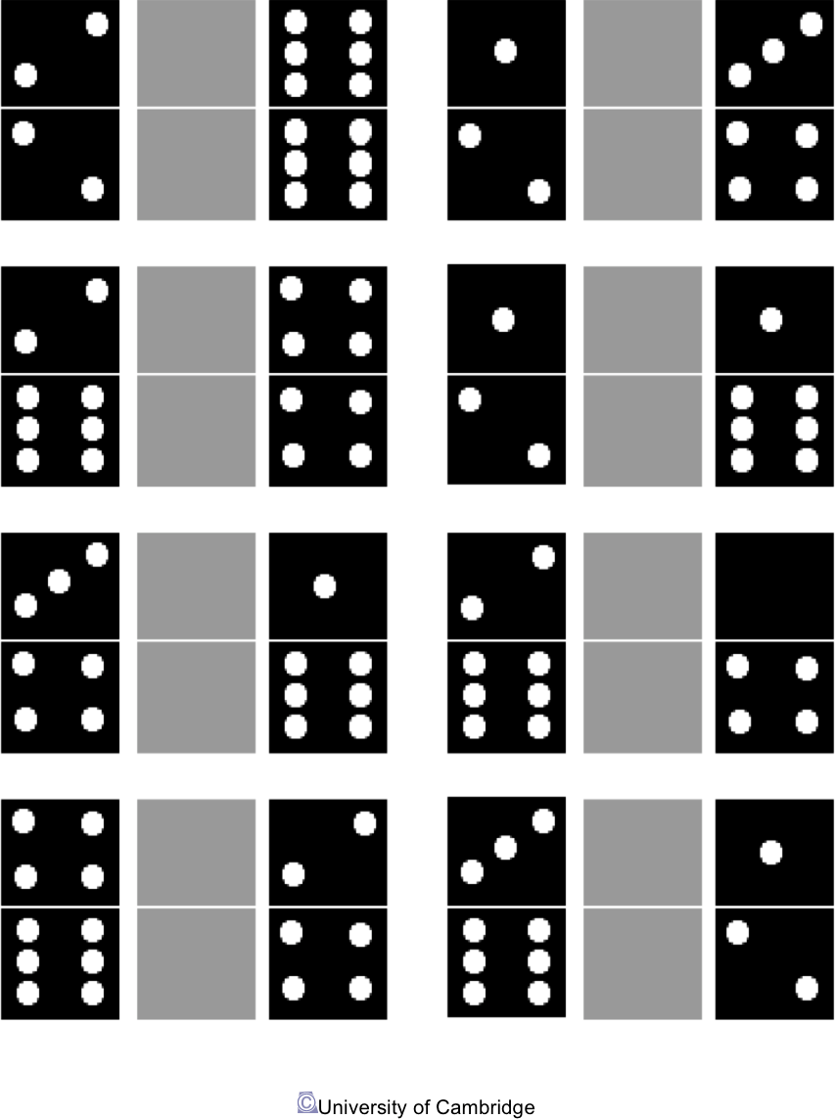


nrich.maths.org/roadshow

