In a town there are three supermarkets: Gary's Groceries, Fiona's Foods and Paul's Provisions.
This week there are special deals on some products at all three shops.
At Gary's Groceries, items are being sold at discount prices.
At Fiona's Foods, you can buy items which are larger than usual.
At Paul's Provisions, there are some "buy one get one free" deals.
 | Gary’s Groceries
Item |   Biscuits |   Oven chips |   Crisps | 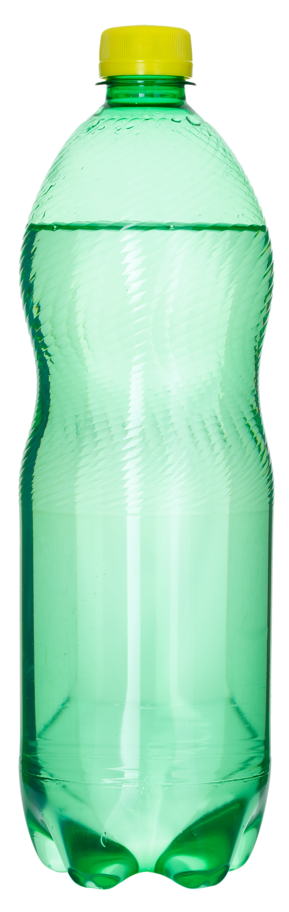  Lemonade | 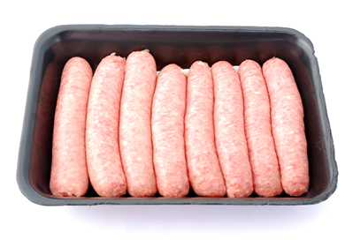  Sausages
Quantity | 7 pack | 1.8kg | 6 pack | 2 litres | 8 pack
Original price | 94p | £1.60 | £1.20 | 55p | £1.85
Special offer | 50% off | 25% off | 35% off | 20% off | 40% off

 | Fiona’s Foods
Item | Biscuits | Oven chips | Crisps | Lemonade | Sausages
Special offer | 40% extra free | 12.5% extra free | 20% extra free | 25% extra free | 60% extra free
New quantity | 7 pack | 1.8kg | 6 pack | 2 litres | 8 pack
Price | 42p | £1.55 | 99p | 43p | £1.04
 | Paul’s Provisions
Item | Biscuits | Oven chips | Crisps | Lemonade | Sausages
Quantity | 7 pack | 1.8kg | 6 pack | 2 litres | 8 pack
Price | 89p | £2.49 | £1.59 | 90p | £2.04
Special offer | Buy one get one free | Buy one get one free | Buy one get one free | Buy one get one free | Buy one get one free
If you shopped at Gary's Groceries, how much would you actually pay for each item? So how much money have you saved on each?
Here is your shopping list:
- 2 bottles of lemonade (2 litre size)
- 1 bag of crisps (6 pack size)
- 24 sausages
- 1 bag of chips (1.8kg size)
If you bought all the items in one shop, where would be the cheapest?
If you could buy the items from different shops, how would you do it to spend the least amount of money?
Apart from the cost, can you think of any other advantages or disadvantages of buying these items at just one shop?
You have £10.70 to spend on a party meal for you and nine friends. Here's your shopping list:
- 4 bottles of lemonade (2 litre size)
- 4 packets of sausages (8 pack size)
- 2 bags of chips (1.8kg size)
- 2 bags of crisps (6 pack size)
- 2 packets of biscuits (7 pack size)
How can you do this without going over your budget?
How many different ways are there?
Which shop offers best value for money on each item?
What sorts of things do you need to take into account to answer this?
Is the "buy one get one free" deal at Paul's Provisions the same as a 50% off deal?

